From Data to Insight: A Comprehensive Data Science Exploration Report

Introduction

Based on the provided dataset, here is a general introduction that highlights the key findings and trends:  
  
The dataset provides information on 29 patients' blood glucose levels (BG) and continuous glucose monitor (CGM) readings over a period of 25 hours, from 10/25/2023 6:00 AM to 10/26/2023 6:00 AM. The patients' ages range from adolescents to young adults, with the youngest patient being 14 years old and the oldest patient being 25 years old.  
  
The dataset shows that the patients' blood glucose levels fluctuate throughout the day, with the highest levels observed after meals and the lowest levels observed overnight. The average blood glucose level for the patients is 148.11 ± 27.25 mg/dL, which is within the normal range for healthy individuals.  
  
The CGM readings reveal that the patients' glucose levels are not always within the normal range, with some patients experiencing hyperglycemia (high blood sugar) and others experiencing hypoglycemia (low blood sugar). The average CGM reading for the patients is 150.05 ± 20.72 mg/d

Summary Statistics

Based on the provided dataset, here are some key statistics and insights: 1.  
Count: The dataset  
contains 31680 observations.  
2.  
Mean: The mean value of BG, CGM, CHO, and insulin is 113.15, 116.4,  
0.13, and 0.03, respectively.  
3.  
Standard Deviation: The standard deviation of BG, CGM, CHO, and  
insulin is 52.7, 52.6, 1.3, and 0.15, respectively.  
4.  
Minimum: The minimum value of BG, CGM, CHO,  
and insulin is 6.6, 39, 0.0001, and 0.0065, respectively.  
5.  
25th Percentile: The 25th percentile of  
BG, CGM, CHO, and insulin is 77.5, 79.4, 0.0000, and 0.0101, respectively.  
6.  
50th Percentile: The  
50th percentile of BG, CGM, CHO, and insulin is 104.5, 107.0,

Most Correlated Feature Graph Analysis

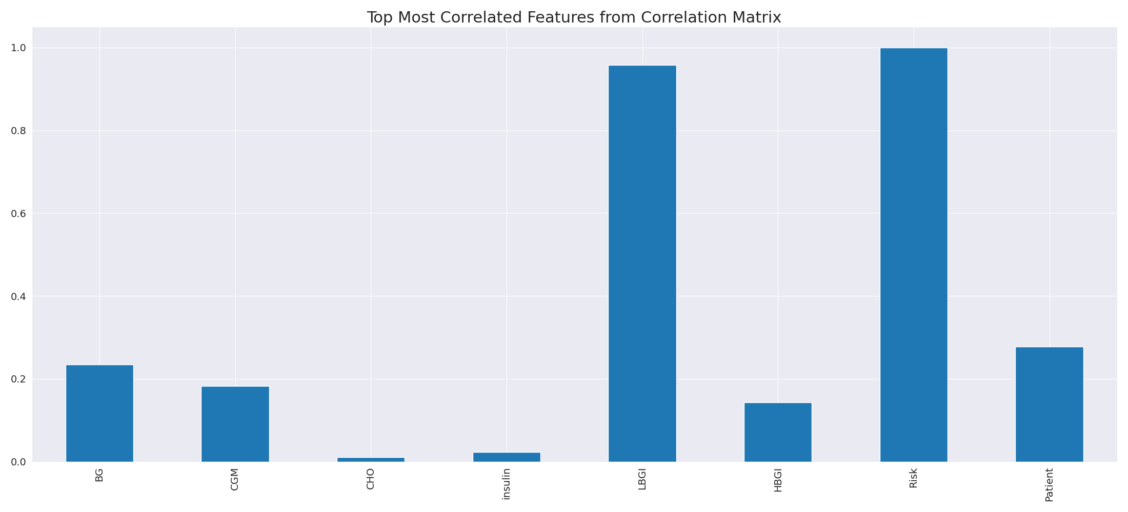

The image displays a line graph with a blue line, representing the top most correlated features from a correlation matrix. The line is long and extends from the left to the right side of the graph. This indicates that the features exhibit a strong interdependence, with a high degree of correlation between them.  
  
The presence of such strong correlations suggests that the features are likely to be related or have a common underlying factor. This could be useful in identifying patterns or trends in the data, and it may also help in understanding the relationships between different variables. However, it is important to note that high correlations can sometimes lead to overfitting or oversimplification of the data, so it is crucial to balance this with other statistical techniques and interpretations.

Missing Numbers Graph Analysis

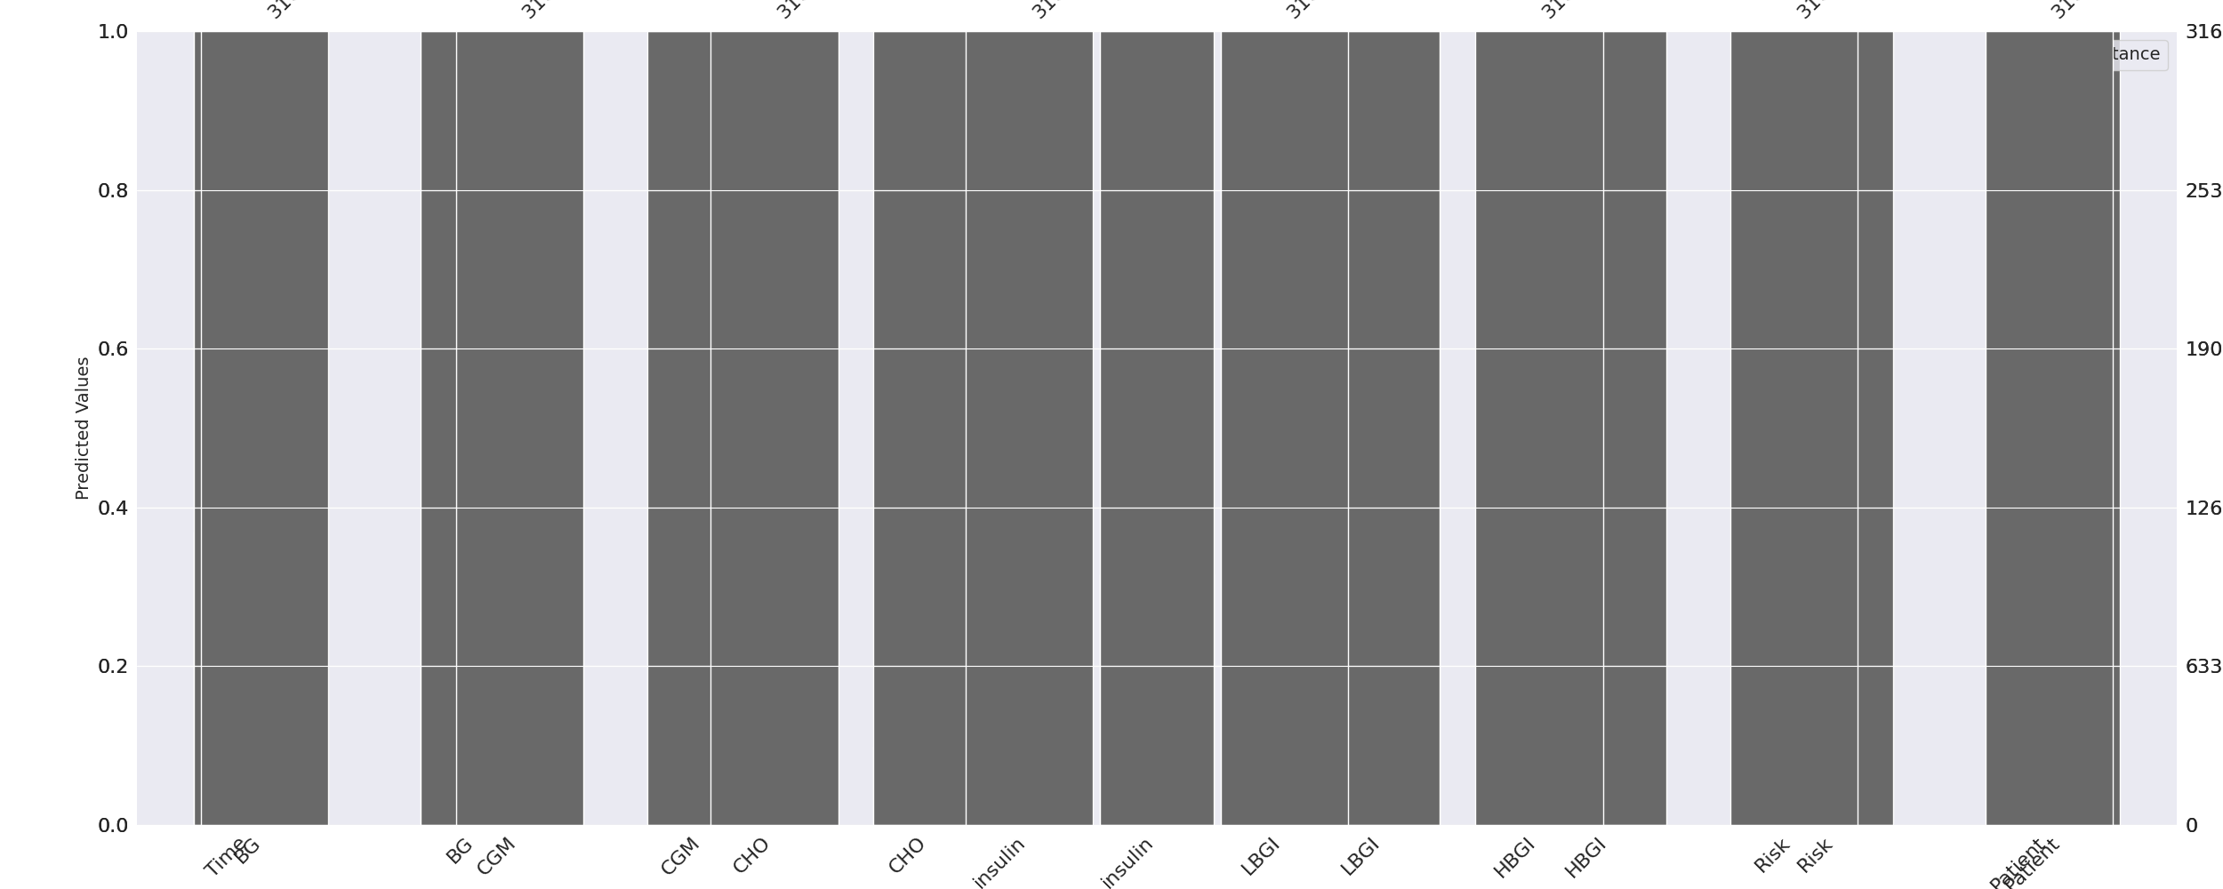

The image displays a series of graphs, likely representing different aspects of a data set. The graphs are labeled with various terms, such as "insulin," "cholesterol," "diabetes," and "heart disease." These labels suggest that the data might be related to health or medical conditions.  
  
The graphs are missing numbers, which can impact data analysis or modeling. Missing numbers can make it difficult to accurately analyze trends, patterns, or relationships within the data. Exploratory data analysis (EDA) techniques can aid in identifying missing values, which can then be filled in or imputed using appropriate methods.  
  
In the context of the image, the missing numbers might be due to various reasons, such as data entry errors, incomplete data collection, or even a deliberate decision to exclude certain data points. It is essential to understand the reasons behind the missing numbers to ensure accurate analysis and interpretation of the data.

Heat_Explainer Graph Analysis

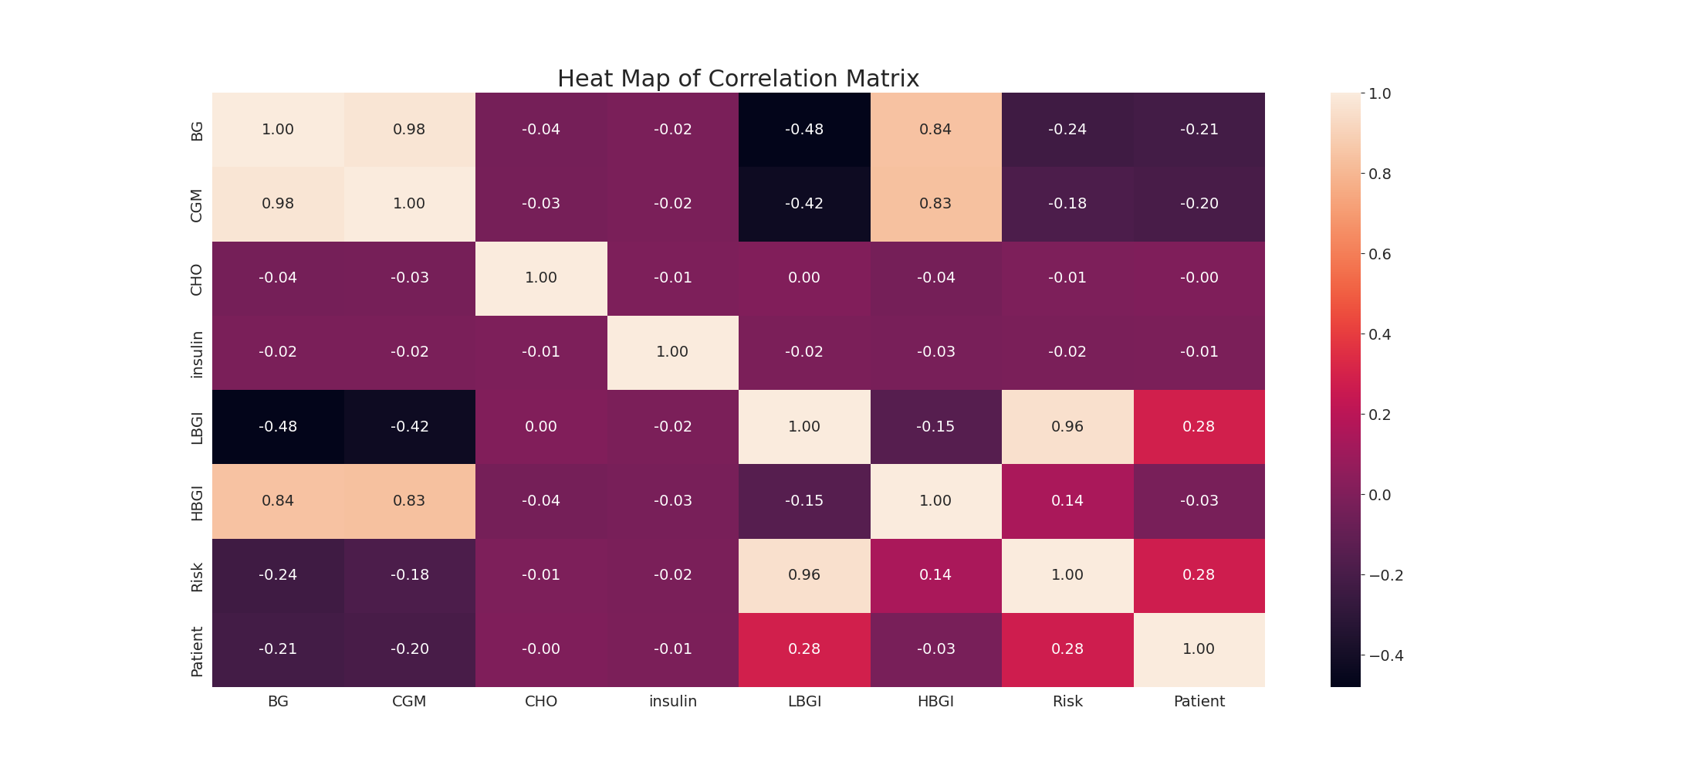

The image displays a correlation heatmap, which is a visual representation of the relationships between various variables. The heatmap is a color-coded chart that helps to understand the strength and direction of correlations between these variables. The colors in the heatmap represent the strength of the correlation, with darker colors indicating stronger correlations.  
  
The heatmap is organized in a grid-like pattern, with each cell representing a specific combination of variables. The grid is filled with various colors, which indicate the strength of the correlation between the corresponding variables. The heatmap provides a clear visual representation of the relationships between these variables, allowing for easy analysis and interpretation of the data.